**Presentation Script: Alzheimer's Disease MRI Dashboard**

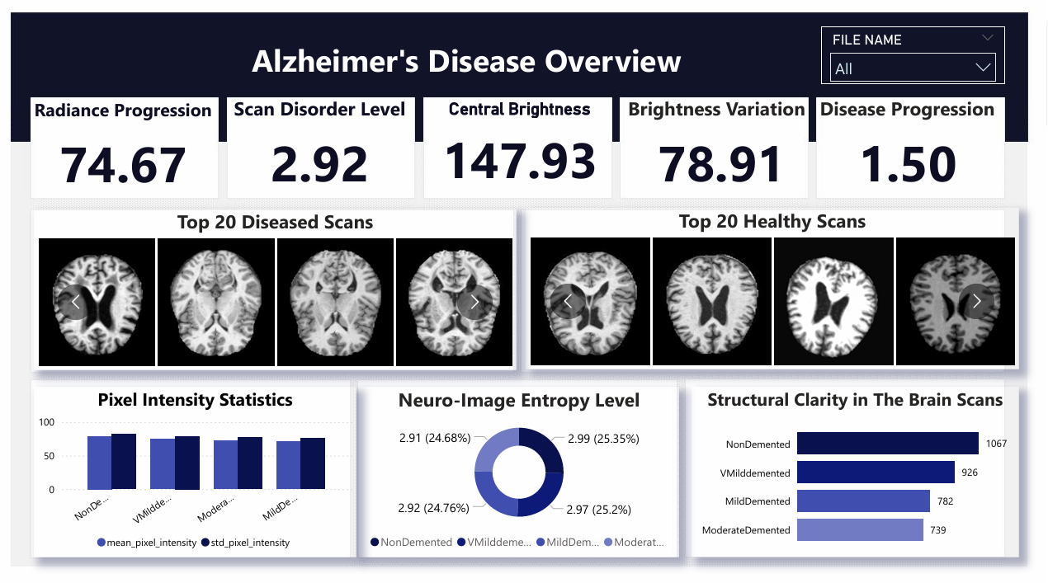

**Slide 1: Title Slide**

* Title: Alzheimer's Disease Detection Using MRI Data
* Presenter: AKPOVETA BLESSING OGHO

"Good afternoon, my name Is Akpoveta Blessing Ogho. Today, I’ll be walking you through a data-driven project that uses MRI brain scan data to detect and analyze Alzheimer’s disease."

**Slide 2: Data Sourcing**

* Source: Kaggle (Alzheimer's Disease MRI Dataset)
* Over 6,400 brain MRI images
* Metadata includes:
  + Filename, Label, Pixel Intensity, Entropy, Edge Density, Brightness, etc.

"The dataset was sourced from Kaggle and contains over 6,000 MRI scans of human brains across various dementia stages. Each image is supported with detailed metadata that enables deeper analysis."

**Slide 3: Data Preparation**

* Removed duplicates
* Cleaned missing values
* Grouped and labeled scans
* Derived key metrics (brightness variation, entropy, etc.)

"I cleaned and prepared the data by removing duplicates and filling missing values. I then grouped the scans by diagnosis and derived additional indicators like brightness variation and entropy."

**Slide 4: Dashboard Overview**

* KPI Cards
* Slizer
* Diseased vs Healthy Scans
* Pixel Intensity Charts
* Entropy Donut Chart
* Structural Clarity Bar Graph

"Here is the final Power BI dashboard. It shows key progression stats, top MRI scans by health condition, and visual insights from entropy, brightness, and intensity levels."

**Slide 5: Independent & Dependent Variables**

* Independent:
  + mean_pixel_intensity
  + std_pixel_intensity
  + entropy
  + edge_density
  + center_brightness
  + is_augmented
* Dependent:
  + Label (Diagnosis)

"The features such as pixel intensity and brightness serve as independent variables, while the diagnosis label is our dependent outcome."

**Slide 6: Stakeholders**

* Neurologists, Radiologists
* Healthcare Data Analysts
* Alzheimer’s Foundations
* Patient Families

"Stakeholders include medical professionals, data scientists, and organizations supporting dementia care and research."

**Slide 7: Insights Derived**

* Diseased brains = higher brightness variation
* Entropy clusters between 2.91 - 2.99
* More NonDemented scans in dataset

"The metrics show diseased brains have elevated brightness and variation. Most entropy values cluster within a tight range but still highlight diagnostic distinctions."

**Slide 8: In-Analysis Observations**

* Strong link: Entropy + brightness + edge density vs. disease stage
* Augmented images slightly affect pixel stats
* Class imbalance present

"We observed clear patterns linking certain pixel metrics to disease stages, though dataset balancing would improve future modeling."

**Slide 9: In-Analysis Recommendations**

* Train AI on entropy + brightness + edge density
* Use structural clarity as a secondary indicator
* Apply data augmentation carefully

"I recommend using entropy, edge density, and brightness as core features in any predictive model, and to balance the dataset for robust training."

**Slide 10: Final Observation**

* Visual scans confirm metric trends
* NonDemented brains = clearer, balanced scans
* Diseased scans = noisy, high variation

"The images and numbers agree—NonDemented brains appear more structurally clear, while others show irregularities consistent with Alzheimer’s effects."

**Slide 11: Final Recommendation**

* Build AI diagnostic assistant
* Use dashboard as a clinical support tool
* Alert systems for early Alzheimer’s signs

"A future-ready tool can alert doctors to early Alzheimer’s signs using this combination of visual and numerical analysis."

**Slide 12: Conclusion**

* Data-driven Alzheimer’s detection is possible
* Visual + Statistical = High accuracy
* Future: Smarter diagnosis, earlier care

"In conclusion, this project shows how pixel-based analysis of MRI images, when combined with dashboards, can revolutionize Alzheimer’s diagnosis. Thank you."